# Ethical Issues Around Data Collection

In this lesson, students will discuss the ethical issues around how and why data is collected. They will look at the risks to personal privacy when working on computer systems and the internet and discuss how computer programs can have beneficial and/or harmful impacts on personal security. Lastly, the importance that programmers have in terms of safeguarding personal privacy will be considered and emphasized. This lesson corresponds with AP Computer Science A topic 7.7.

## Objective

Students will be able to:

* Explain the risks to privacy from collecting and storing personal data on computer systems
* Explain the role that programmers have considering safeguarding personal privacy
* Explain the beneficial and harmful impacts that computer use and the creation of programs have on personal security

## The Curly Fry Conundrum

View the following Ted Talk (Jennifer Golbeck): “Your Social Media Likes Expose More Than You Think.”

<https://www.ted.com/talks/jennifer_golbeck_the_curly_fry_conundrum_why_social_media_likes_say_more_than_you_might_think/transcript?referrer=playlist-what_your_data_reveals_about_y#t-413224>

1. Explain what homophily is and how it relates to “the curly fry conundrum” explained in the video.
2. Think of all the ways you interact and share your data online. Give an example of data that you share and how that data might be used by researchers or advertisers.
3. Reflect on the closing statement by Golbeck below. How do you think we can have a more “educated and empowered user base”?

“And so I think encouraging this kind of science and supporting researchers who want to cede some of that control back to users and away from the social media companies means that going forward, as these tools evolve and advance, means that we’re going to have an educated and empowered user base, and I think all of us can agree that that’s a pretty ideal way to go forward.”

## Guidelines on Ethical Data Use

The [previous article](https://drive.google.com/file/d/1oCA08hzGksV0VMS0LOjN4tiKqWet3ocU/view?usp=sharing) lists 5 issues to consider when thinking about how to improve ethical data collection, storage and research. After reading the article, select ONE of the 5 issues that you feel is the most important and do a little more of your own research. Use the following key word search: issue + ethical data. For example, with the 2nd issue, your keyword search would be “privacy confidentiality ethical data.”

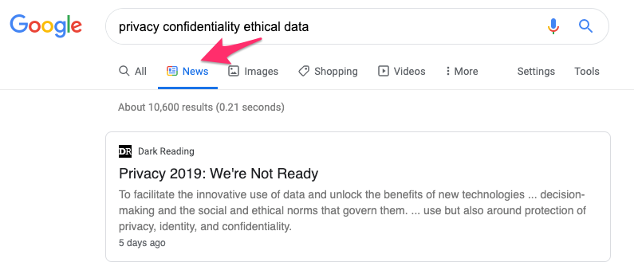

1. Then, filter by the “News” category and select an additional article/resource to read.
2. In your response here, state why you believe the issue you chose is the most important consideration when it comes to ethical data collection. Then give a ONE paragraph summary of the second related news resource you chose.